TASK 1

Query 1

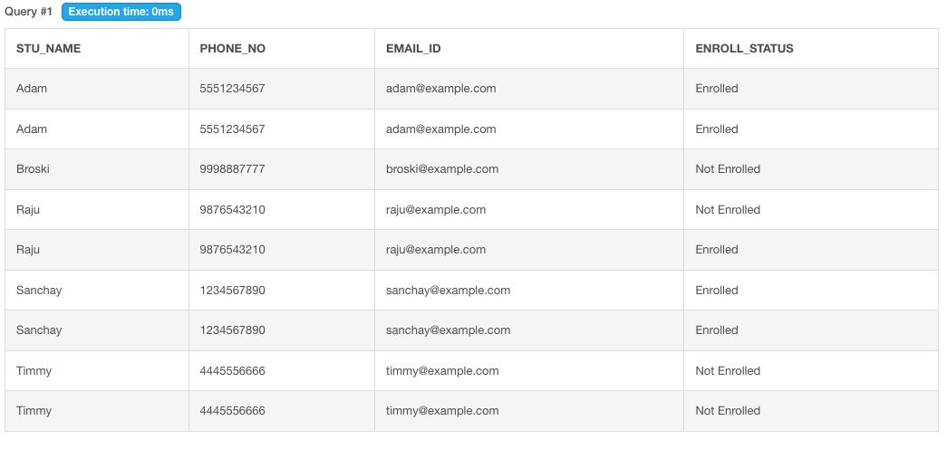

Query 2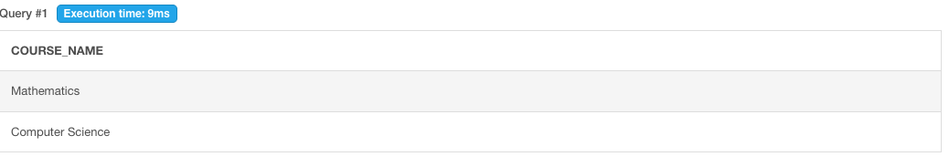

Query 3

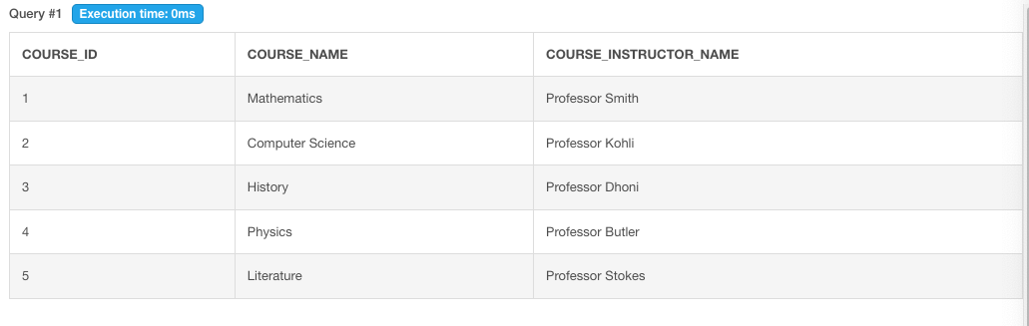

Query 4

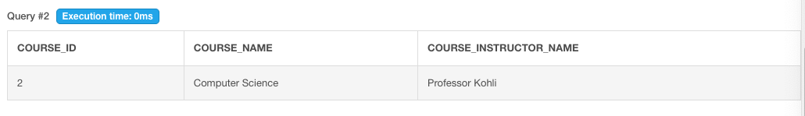

Query 5

